|  |
| --- |
|  |
|  |
|  |
|  |
| SOFTWARE ENGINEERING |
| student : Ali abbas |
| Instructor : Saira khurram |

**PROJECT REPORT**

**HEALTH CARE**

**MANAGEMENT SYSTEM**

**ACKNOWLEDGEMENT**

In addition to the team's combined efforts, the success of every project is greatly affected by the support and guidance of multiple people. We would want to use this opportunity to express our gratitude to everyone who helped make this initiative a great success. The successful execution of diverse initiatives is contingent upon the cooperation, coordination, and coordinated efforts of many knowledge providers.

We express our profound gratitude to “**Mam Saira Khurram**” our Software Engineering instructor, for her unwavering commitment to providing invaluable advice and guidance, under which we executed this project. Her continuous mentorship and readiness to share her extensive knowledge deepened our understanding of the project and its intricacies, enabling us to successfully accomplish the assigned tasks.

A project report serves as a conduit between theoretical and practical learning, and with this perspective, we diligently worked on this report. The timely support and collective endeavors of all those who assisted us were pivotal in making this report a success.

**DESCRIPTION OF THE SYSTEM:**

A healthcare management system is a web-based application specifically designed for hospitals to efficiently oversee staff and patient information. The primary objective behind the development of the "**HEALTH CARE MANAGEMENT SYSTEM**" is to automate the front-office management of hospitals. Tailored for multi-specialty healthcare institutions, the Hospital Management System encompasses a wide spectrum of administrative and managerial processes within the hospital. The project involves patient registration, systematic data storage, and computerized billing in both the pharmacy and laboratories. Accurate record-keeping and streamlined communication are paramount in the healthcare sector. The software is equipped to assign a unique identifier to each patient and automatically store comprehensive details of both patients and staff members.

Given the escalating demand in hospitals, there is a pressing need for an efficient data management system that can handle patient data, staff information, and treatment specifics. The system focuses on collecting patient information, including diagnosis details, and provides a search function to ascertain the current status of each room. Utilizing the assigned identifiers, users can access a doctor's availability and retrieve patient information.

The implementation of this software is expected to enhance the company's efficiency in patient registration and appointment management, as well as maintaining accurate patient records. It empowers doctors and administrators to effortlessly view and modify appointment schedules as needed. The overarching goal of this project is to digitize all aspects related to patient and hospital details.

**SCOPE OF THE SYSTEM:**

The Health Care Management System is designed to cater to the operational requirements of various healthcare facilities, including hospitals, clinics, dispensaries, and other health institutions. Its primary goal is to improve patient care by optimizing the management of healthcare processes and resources.

In contrast to traditional file-based hospital management systems, there are significant challenges. These systems require substantial efforts to ensure the physical security of paper records. The susceptibility to threats such as fire, insect damage, and natural disasters poses a notable risk to the integrity and availability of patient data. Additionally, the potential for data misplacement or loss compounds the inefficiencies associated with paper-based record-keeping.

Transitioning to a digital Health Care Management System helps mitigate these risks and streamline operations. The system's digital nature not only enhances data security but also improves accessibility, enabling the seamless management of patient records, appointments, and treatments. Ultimately, the system aims to optimize healthcare processes and resources for enhanced patient care.

**FUNCTIONAL REQUIREMENTS OF HEALTH CARE MANAGEMENT SYSTEM:**

**User Registration and Authentication:**

* Users should be able to register for the system.
* The system should authenticate users securely.

**Patient Management:**

* Add, edit, and delete patient records.
* Maintain patient demographic information.
* Record medical history and allergies.
* Assign unique patient identifiers.

**Appointment Scheduling:**

* Schedule patient appointments with healthcare providers.
* Allow users to view and manage their appointments.
* Send appointment reminders to patients.

**Electronic Health Records (EHR):**

* Store and manage electronic health records securely.
* Allow authorized users to access and update patient records.
* Support documentation of diagnoses, treatments, and lab results.

**Prescription Management:**

* Enable healthcare providers to prescribe medications.
* Maintain a record of prescribed medications.
* Support medication refills and dosage adjustments.
* Billing and Invoicing: Generate and send bills to patients and insurance providers.
* Record payment transactions and payment history.

**Insurance Verification:**

* Verify patient insurance information for eligibility and coverage.
* Submit insurance claims electronically.
* Telemedicine: Facilitate remote doctor-patient consultations.
* Provide secure video conferencing and messaging.

**Inventory Management:**

* Track and manage medical supplies and equipment.
* Alert staff when supplies are low.

**Reporting and Analytics:**

* Generate reports on patient demographics, financials, and operational metrics.
* Provide data analytics for healthcare providers to improve patient care and operations.

**NON-FUNCTIONAL REQUIREMENTS OF HEALTH CARE MANAGEMENT SYSTEM**

* **Security:**
  + Ensure data privacy and compliance with healthcare regulations (HIPAA, GDPR).
  + Implement role-based access control.
  + Encrypt sensitive data during transmission and storage.
* **Scalability:**
  + Support the ability to scale the system to accommodate a growing number of users and patient records.
* **Performance:**
  + Ensure fast response times for critical functions, such as patient record retrieval.
  + Handle concurrent user requests efficiently.
* **Reliability:**
  + Minimize system downtime and ensure high availability.
  + Implement data backup and disaster recovery procedures.
* **Usability:**
  + Design an intuitive and user-friendly interface.
  + Provide training and documentation for users.
  + Interoperability:
  + Integrate with other healthcare systems and external entities (e.g., labs, pharmacies) using standard protocols.
* **Compliance:**
  + Ensure compliance with healthcare regulations, including data retention and reporting requirements.
* **Auditability:**
  + Maintain a comprehensive audit trail of user actions within the system.
* **Load Testing:**
  + Conduct load testing to ensure the system can handle peak loads without performance degradation.
* **Data Backup and Recovery:**
  + Implement regular data backups and establish a disaster recovery plan to prevent data loss.

**META DATA**

**ACTORS FOR HELTHCACRE MANAGEMENT SYSTEM:**

* New user/ Patient
* Registered user
* Health care provider
* Administration
* Billing & Finance
* Pharmacist

**USE CASES FOR HEALTHCARE MANAGEMENT SYSTEM:**

* User Registration
* Login
* Patient Record Management
* Appointment Scheduling
* Prescription Management
* Billing and Payment
* Administrator's Dashboard

Use Case Narratives:

**1) User Registration:**

* + ***Description:*** This use case involves individuals, including patients, healthcare providers, and administrators, registering for an account in the healthcare management system.
  + ***Actors****:* Patient, Registered User, Health Care Provider, Administrator

**Primary Flow:**

1. User accesses the registration page and provides personal information.
2. System validates the information and sends a confirmation email.
3. User clicks on the confirmation link in the email to activate the account.
4. The system notifies the administrator of the new registration.
5. Administrator reviews and approves the registration, activating the user account.

**Alternative Flow:**

1. User accesses the registration page and provides personal information.
2. Instead of an email confirmation, the system sends a temporary SMS code to the user's registered mobile number.
3. User enters the SMS code to complete the registration process.
4. Upon successful verification, the system automatically approves the registration, activating the user account.
5. **Login:**
   * ***Description:*** This use case allows users (including patients, healthcare providers, administrators, and pharmacists) to log in to their accounts in the healthcare management system.
   * ***Actors****:* Patient, Registered User, Health Care Provider, Administrator, Pharmacist, Billing Finance

**Primary Flow:**

1. User enters credentials on the login page.
2. System verifies credentials and redirects users to their respective dashboards.
3. Administrators access a separate login interface and enter credentials for the administrator dashboard.

**Alternative Flow:**

1. User enters credentials on the login page.
2. System verifies credentials and prompts users for a fingerprint or face scan for additional authentication.
3. Users are redirected to a personalized dashboard based on their historical interactions and preferences.
4. **Patient Record Management:**
   * ***Description****:* This use case involves the creation, updating, and retrieval of patient records by healthcare providers.
   * ***Actors:*** Health Care Provider

**Primary Flow:**

1. Healthcare provider logs in and selects "Patient Record Management."
2. System displays a list of patients; the provider selects a patient to view or update information.
3. Provider updates relevant information and saves changes.
4. Provider can view a patient's medical history and other details.

**Alternative Flow:**

1. Healthcare provider logs in and initiates a secure video consultation with the patient.
2. During the video call, provider and patient collaboratively update the patient's record in real-time.
3. Changes made during the consultation are automatically saved to the patient's record.
4. **Appointment Scheduling:**
   * ***Description:*** Patients can request and schedule appointments with healthcare providers.
   * ***Actors:*** Patient, Health Care Provider

**Primary Flow:**

1. Patient logs in and selects "Appointment Scheduling."
2. Patient chooses a healthcare provider, specifies preferred dates/times, and submits the request.
3. Healthcare provider reviews the request and confirms or suggests alternative dates/times.
4. Patient receives confirmation or alternative suggestions.

**Alternative Flow:**

1. Patient logs in and selects "Appointment Scheduling."
2. The system suggests available time slots based on both patient and healthcare provider calendars.
3. Patient and provider engage in a real-time chat to finalize appointment details.
4. Upon confirmation, the system automatically schedules the appointment and sends instant notifications.
5. **Prescription Management:**
   * ***Description:*** Healthcare providers can prescribe medications and manage patient prescriptions.
   * ***Actors:*** Health Care Provider, Pharmacist

**Primary Flow:**

* + 1. Healthcare provider accesses the patient's record and selects "Prescription Management."
    2. Provider enters prescription details.
    3. System updates the patient's record with the prescription information.
    4. Pharmacist can access prescription details and dispense medications accordingly.

**Alternative Flow:**

* 1. Healthcare provider accesses the patient's record and uses an AI-powered prescription assistant.
  2. The AI assists in verifying medication compatibility and dosage.
  3. The prescription is then reviewed by the provider before saving it to the patient's record.

.

1. **Billing and Payment:**
   * ***Description:*** This use case involves generating bills for services rendered and facilitating patient payments.
   * ***Actors:*** Administrator, Patient, Billing Finance

**Primary Flow:**

1. Healthcare provider logs services in the patient's record.
2. Administrator generates a bill.
3. Billing Finance reviews bills and manages payment processing.
4. Patient receives a notification, views the bill, and makes a payment through the system.

**Alternative Flow:**

1. Healthcare provider logs services rendered in the patient's record.
2. The system generates an interactive, real-time billing summary.
3. Billing Finance reviews the summary and sends an instant payment request with a personalized payment link to the patient.
4. Patient clicks on the link, confirming payment through a secure mobile payment interface.
5. **Administrator Dashboard:**
   * ***Description:*** Administrators have access to a dashboard that provides an overview of the system and tools for system management.
   * ***Actors:*** Administrator

**Primary Flow**:

1. Administrator logs in and is redirected to the administrator dashboard.
2. Dashboard displays system statistics, user activity, and relevant alerts.
3. Administrator can access tools for user management, system configuration, and report generation.

**Alternative Flow:**

1. Administrator logs in and is redirected to an AI-enhanced dashboard.
2. The dashboard includes customizable widgets for real-time data analytics and insights.
3. AI-driven alerts highlight potential issues, and the administrator can click for detailed recommendations.
4. The administrator can drag-and-drop widgets to tailor the dashboard layout based on their immediate needs.

## Use Case Diagram

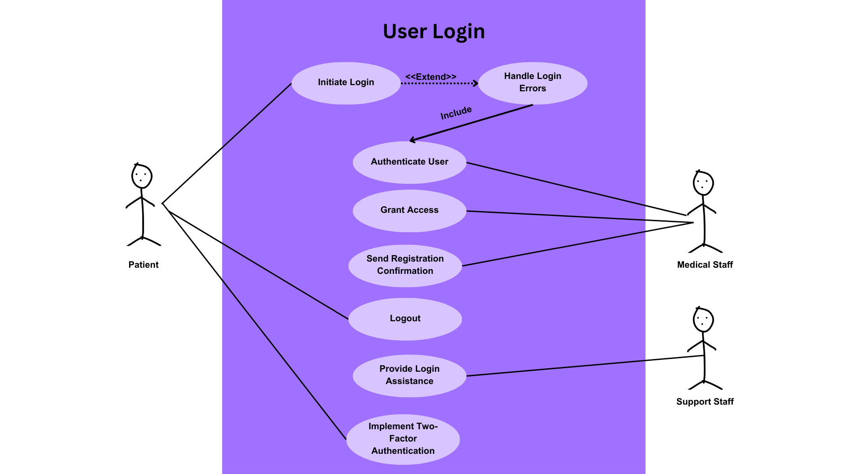

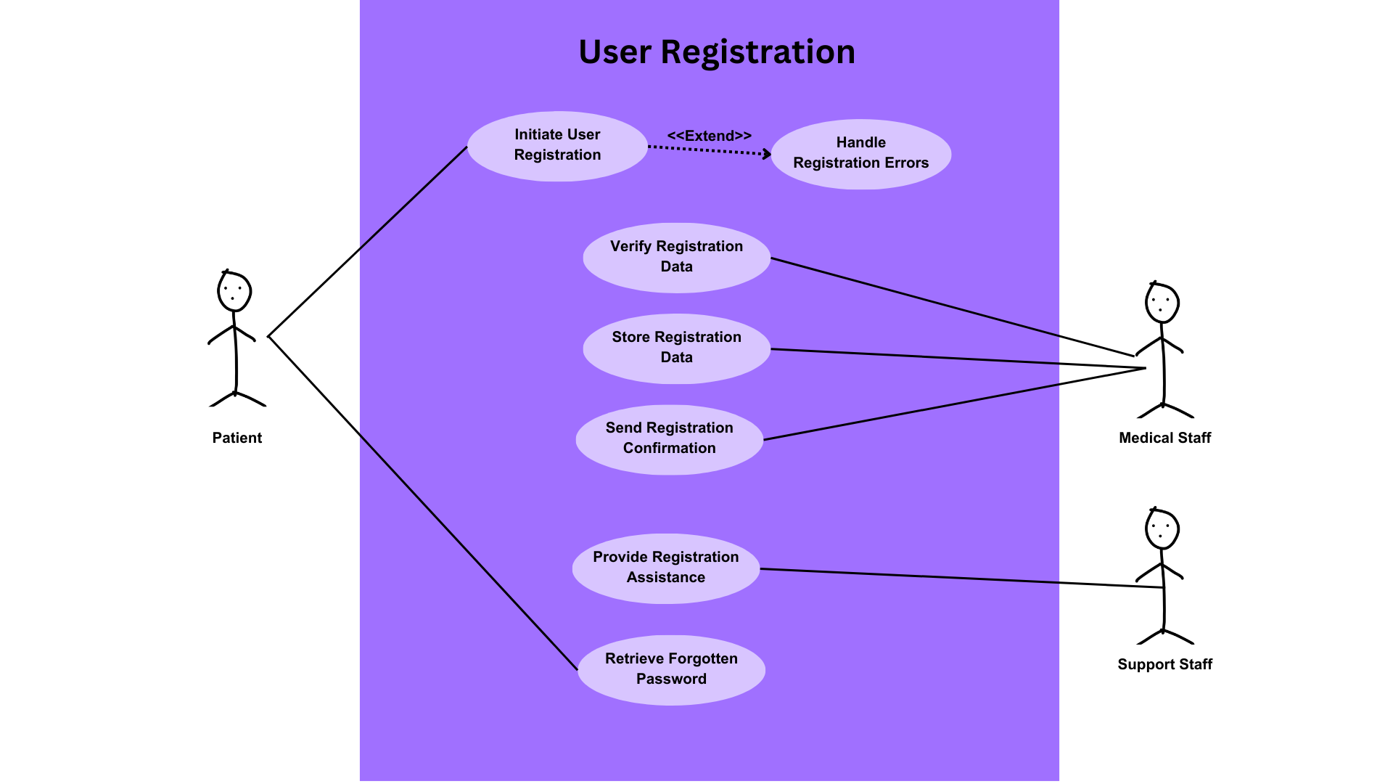

## 

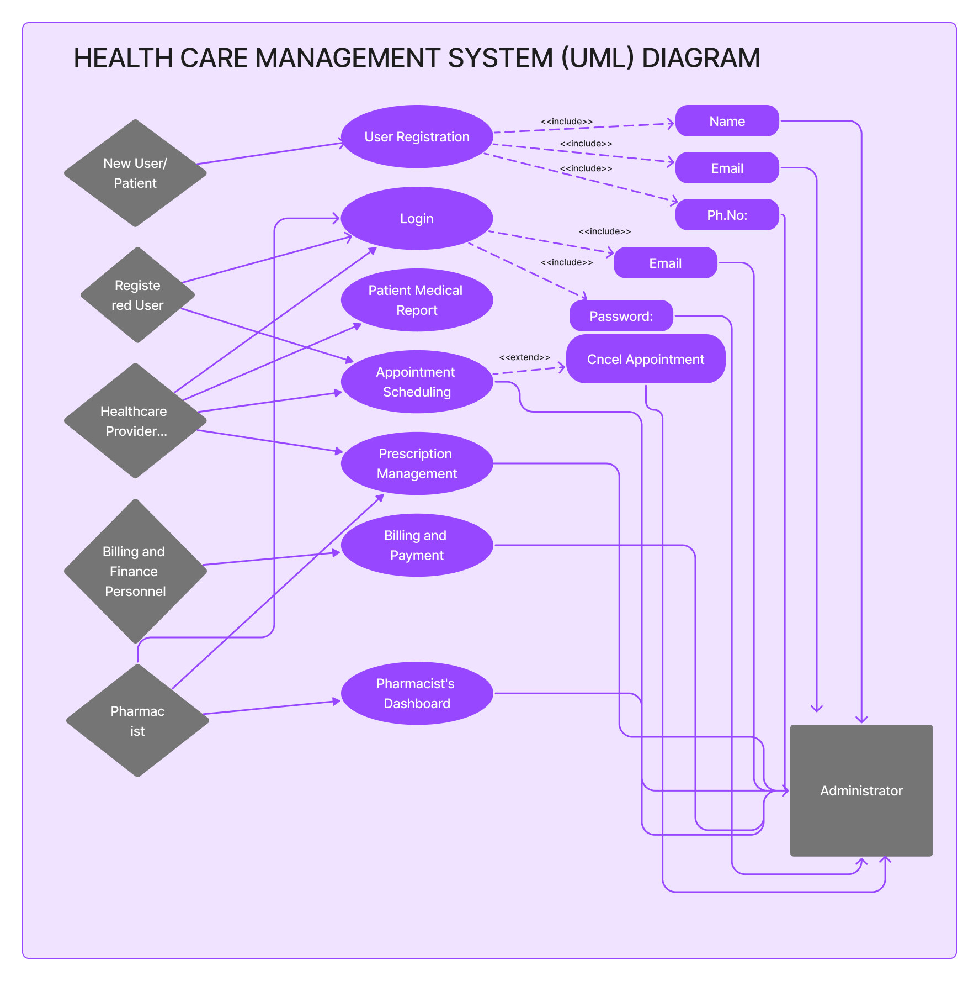

UML Diagram

DFD Diagram (Context Diagram)

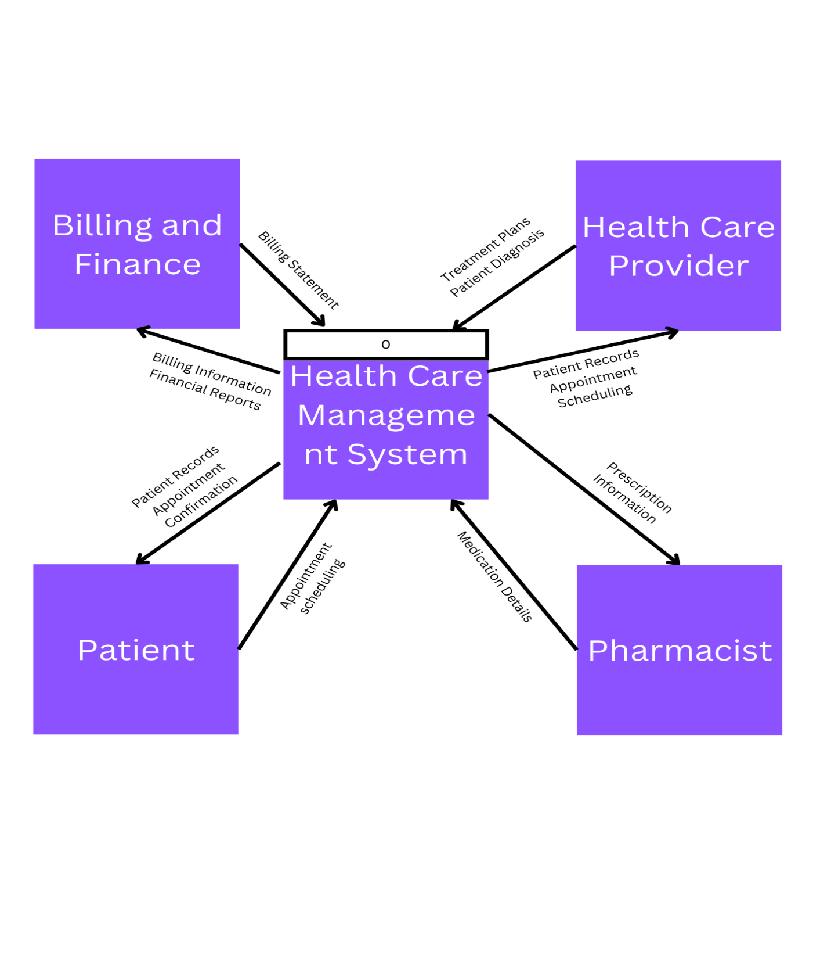

DFD Diagram (0)

[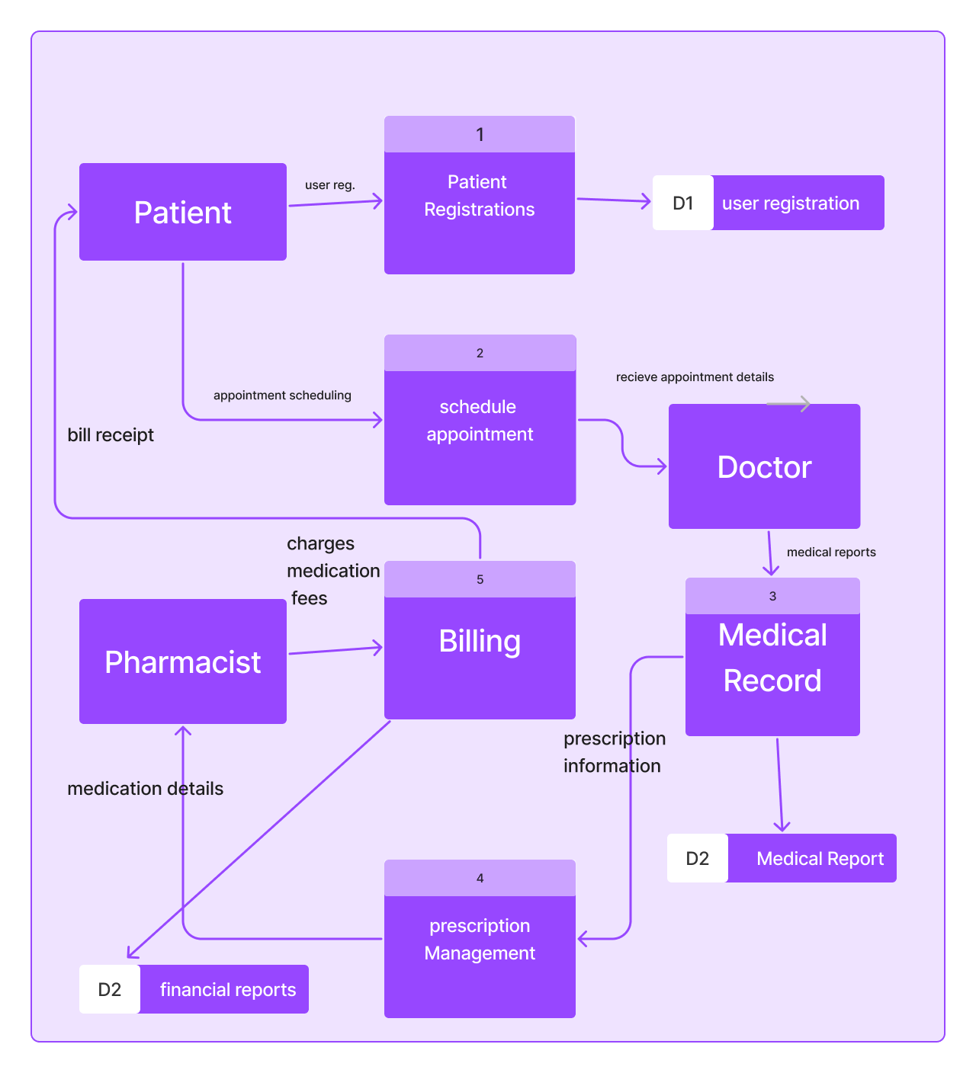](DFD1)s

## **DFD Diagram 1**

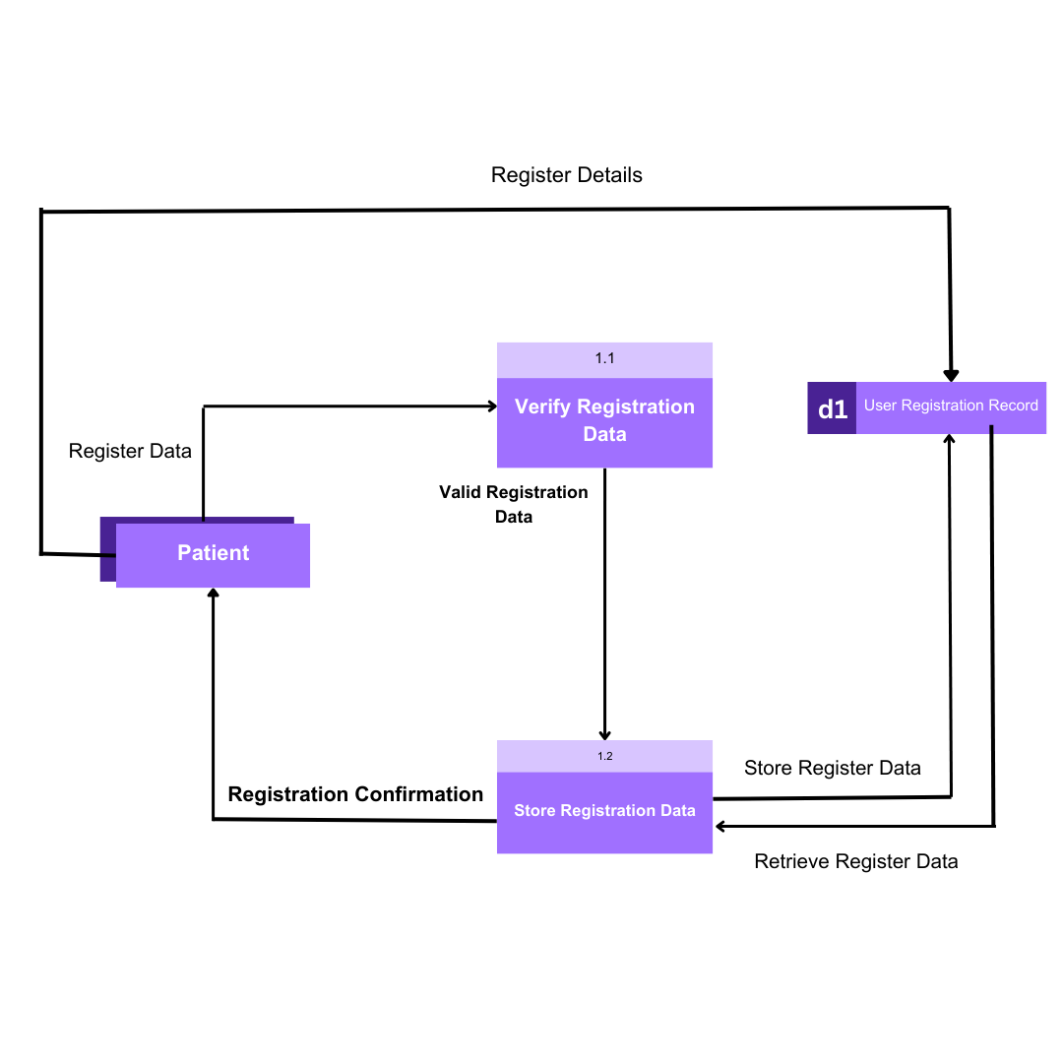

DFD Diagram 2

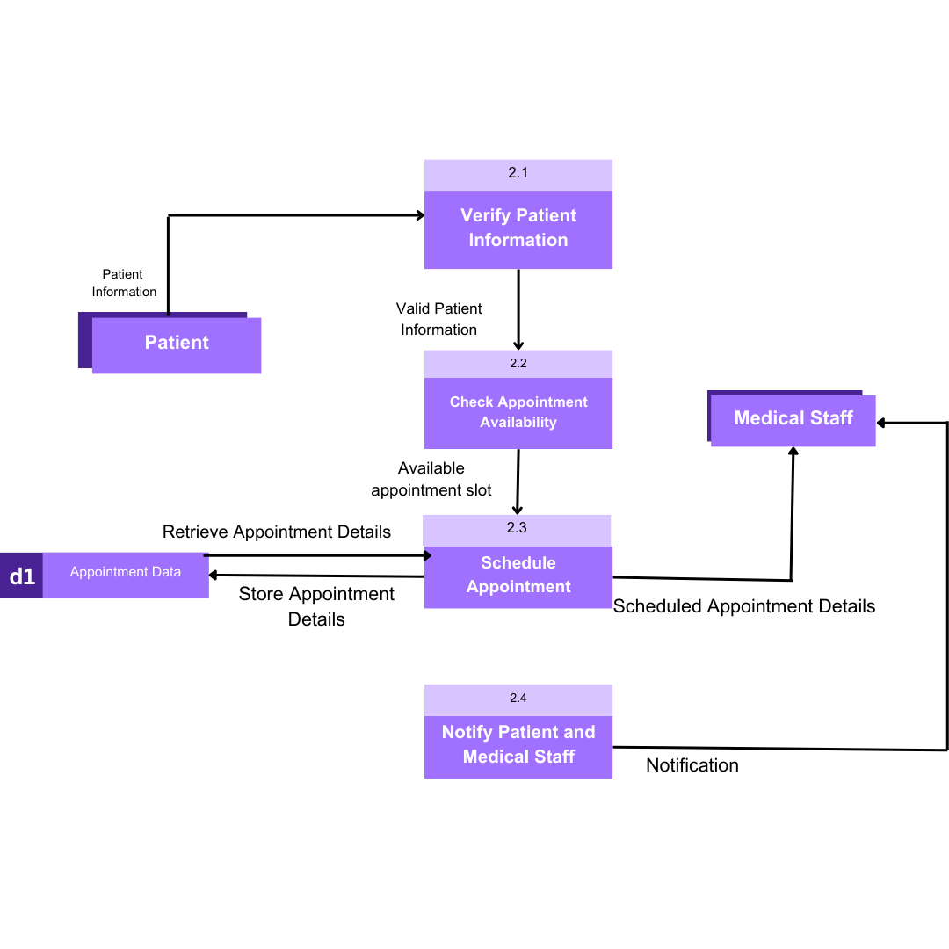

**APPROPRIATE PROCESS MODEL**

Selecting the appropriate process model for your Hospital Management System (HMS) project is crucial for its successful development. The choice of the process model should align with the project's complexity, requirements, and goals. Here, I'll suggest an appropriate process model for your proposed HMS and provide detailed insights into the choice.

**Appropriate Process Model:**

**Incremental Development (Iterative Model):**

The Incremental Development process model, also known as the Iterative Model, is well-suited for the development of complex systems like a Hospital Management System. It offers several advantages that align with the project's needs:

1. **Complexity Handling**:

HMS projects are inherently complex, involving multiple modules, users, and functionalities. The Incremental Development model allows you to break down the complexity into smaller, manageable increments or iterations. Each iteration focuses on a specific set of features or functionality.

1. **Continuous Improvement:**

In healthcare, requirements may evolve as regulations change or new needs arise. The iterative approach allows for continuous improvement and adaptation to changing requirements. Each iteration can incorporate feedback from users and stakeholders, ensuring that the system remains aligned with real-world needs.

1. **Risk Mitigation:**

Hospitals and healthcare systems deal with sensitive patient data, and system reliability is paramount. Incremental Development helps identify and address risks early in the development process. You can prioritize high-risk components and ensure they are thoroughly tested and validated before moving to subsequent iterations.

1. **User Involvement:**

HMS projects involve various stakeholders, including healthcare providers, administrators, and patients. The iterative model encourages regular interaction and feedback from these stakeholders. It ensures that the system meets their specific needs and expectations.

## Risk Management

|  |  |  |  |  |
| --- | --- | --- | --- | --- |
| Risk Description | Likelihood | Impact | Mitigation Strategy | |
| Data Breach | High | High | Implement robust data encryption and access controls. Conduct regular security audits. |
| System Downtime | Moderate | High | Set up redundant servers, perform regular maintenance, and establish a backup and recovery plan. |
| Inadequate User Training | Moderate | Medium | Develop comprehensive training programs for users. Provide ongoing support and documentation. |
| Change in Regulatory Requirements | Low | High | Stay informed about healthcare regulations. Regularly review and update the system to comply with changes. |
| Integration Issues with External Systems | Moderate | Medium | Prioritize compatibility testing with external systems. Establish clear communication channels with third-party providers. |
| Insufficient Scalability | Moderate | Medium | Design the system with scalability in mind. Regularly assess and upgrade the infrastructure as needed. |
| Vendor Dependency | Low | High | Diversify vendors and maintain good relationships. Include contingency plans for vendor-related issues. |